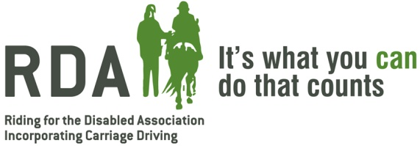

Anne Thorpe Memorial Trophy 2019
Celebrating the achievements of RDA participants in the North West

The Anne Thorpe Memorial Trophy is awarded for participant achievement in the North West Region over the previous 12 months. Anne Thorpe was the first Regional Chairman and supported RDA for over 35 years. This form should be completed by a Group Instructor or Trustee. The North West Regional Committee will appoint judges to carefully review all entrants and award an overall winner based on the criteria and information given below.

RDA Group | Click here to enter text.
Name of person nominating participant | Click here to enter text.
Position of person nominating e.g. Instructor / Trustee / Volunteer | Click here to enter text.
Name of participant | Click here to enter text.
Age of participant (use dropdown list) | Choose an item.
Role of participant (use dropdown list) | Choose an item.
Date started with Group (mm/yy) | Click here to enter text.
Brief details of disability | Click here to enter text.

Please read through the criteria below against which your participant’s achievements will be measured. You should ensure that your application addresses at least one of these areas. Use the space below to tell us why your participant should win this trophy.
Click here to enter text.

These are the criteria which your participant’s achievement will be measured against so you should ensure that your application addresses at least one of these areas.
Criteria | Description
Criteria 1 | Communication: achievements in verbal or physical communication
Criteria 2 | Confidence: achievements relating to RDA activities including enjoyment of sessions
Criteria 3 | Relationships: with horses, volunteers and other riders
Criteria 4 | Physical changes to riders condition that you attribute to RDA achievement
Criteria 5 | Horsemanship: significant improvement in rider / driver / vaulter skills

Is there any other information you wish to give in support of this application?
Click here to enter text.

Please return this form to Gill Petty at gillpetty@hotmail.co.uk by 16th October 2019

