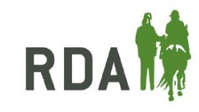
North West Riding for the Disabled
2020 Riding Holiday Application Form

Applications are now open for the 2020 North West RDA riding holiday at Clwyd Special Riding Centre on Friday 12th June – Sunday 14th June. Please complete one form below for each rider and return it to gillpetty@hotmail.co.uk by 1st April 2020.

Information about your group
Please select your group from the dropdown List | Select your group
Name of coach making application
Telephone number of coach making application
Email address of coach making application

Information about your applicant
Name
Address
Postcode
Telephone
Email
Height and weight
Date of birth
Start date with your group
Independent in walk / trot (Y / N)
Attended RDA holiday before (Y/N)
One carer place will be required (Y/N)
Basic disability information
Any other relevant information

